2.82: a)
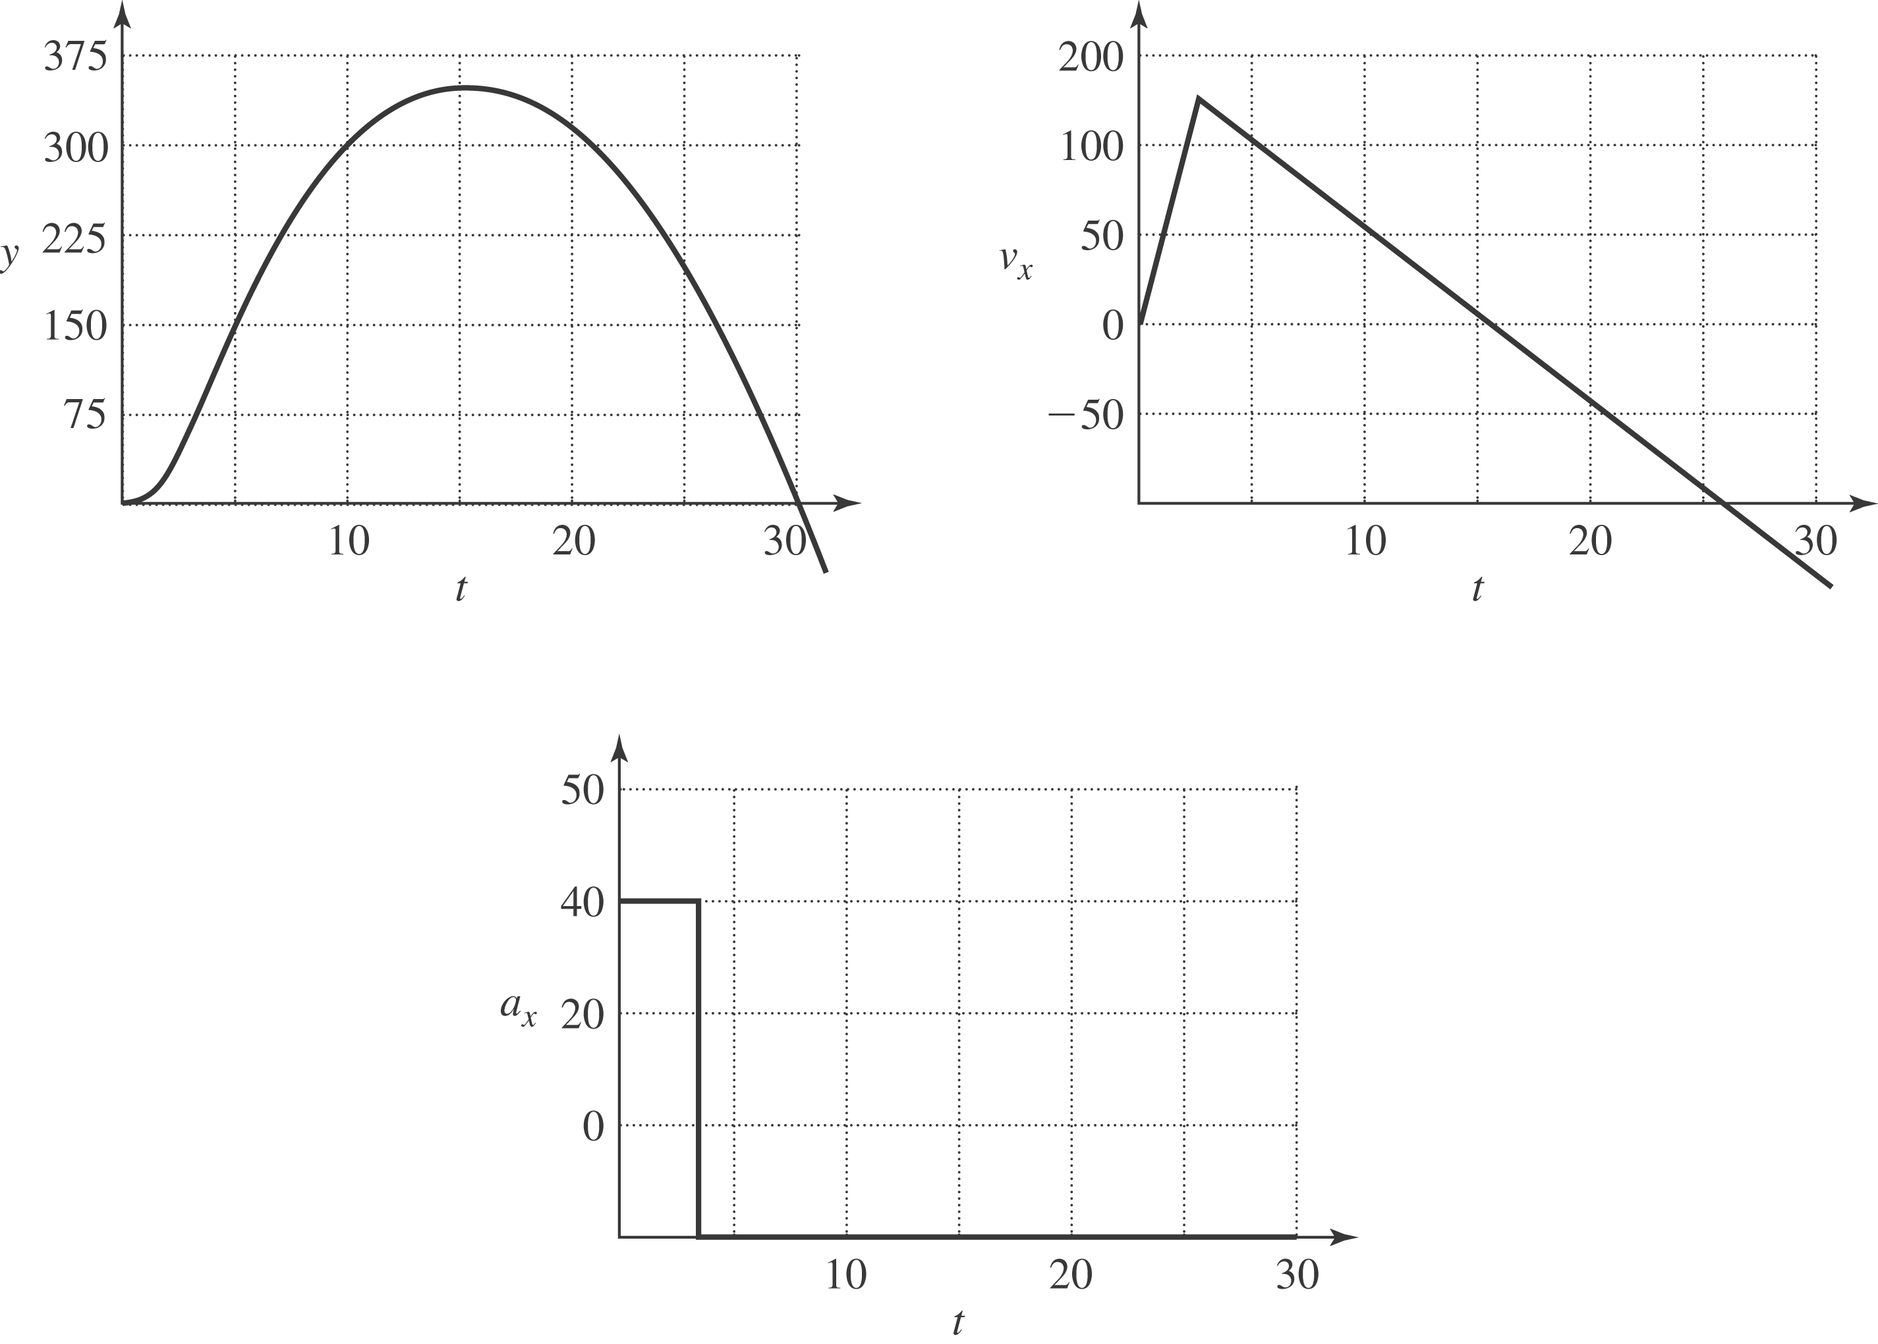

b) From the speed found in part (c), the maximum height is

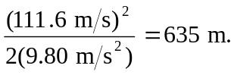

c) After the fuel is burned, the rocket has speed (40.0 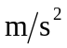)(2.50 s) = 100 m/s and has reached a height ()(40.0 )(2.50 s)² = 125 m. The speed of the rocket just before it hits the ground is then

or 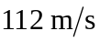to three significant figures.

d) The time from launch to the highest point is not the same as the time from the highest point back to the ground due to the upward acceleration of the engine in the first 2.5 s.

